Design Document: Purchasing

**Vendor Selection (<asp:DropDownList>)**

[DataObjectMethod(DataObjectMethodType.Select)]

Public List<VendorInfo> ListVendorNames()

Protected void Select_VendorClick (object sender, EventArgs e)

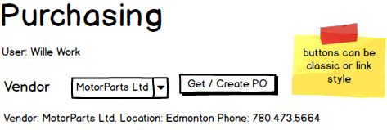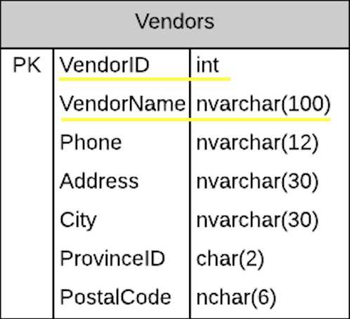

Selecting a Vendor

- Vendor Summary Info (Disabled Text Boxes)

[DataObjectMethod(DataObjectMethodType.Select)]

Public VendorInfo GetVendorSummary (int vendorID)

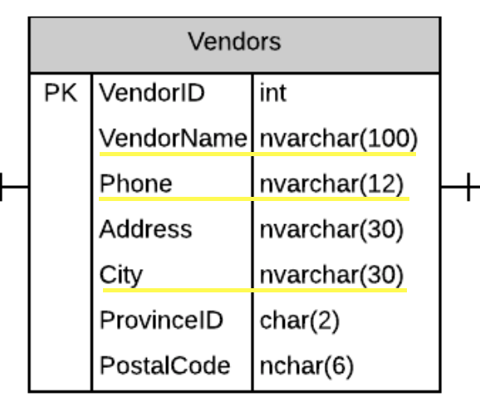

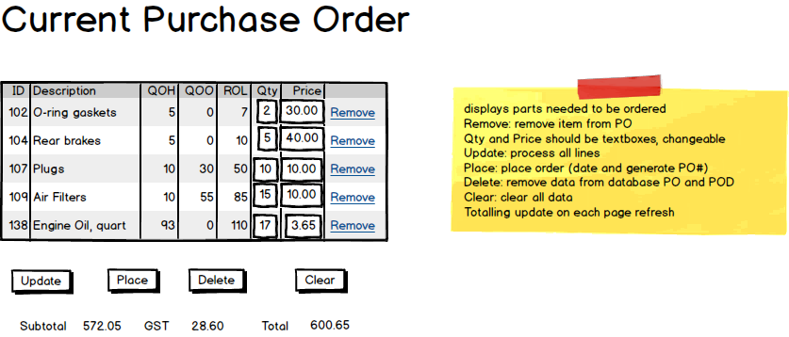

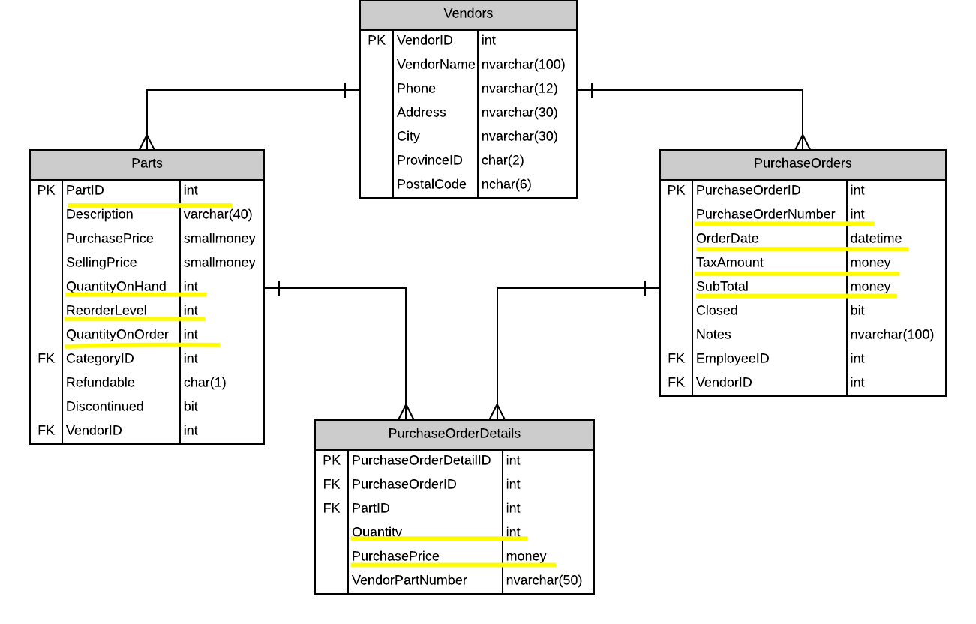

Current Order

- CurrentOrder (<asp:Gridview>)

Public CurrentOrderDetails GetCurrentOrder (int vendorID)

Suggested Order

- SuggestedOrder

Get/ Create Purchase Order Button

Public SuggestedOrder GetSuggestedOrderForVendor (int vendorID)

Current Inventory

- CurrentOrder (<asp:Gridview>)

[DataObjectMethod(DataObjectMethodType.Select)]

Public List<CurrentInventory> GetInventoryForVendor (int vendorID)

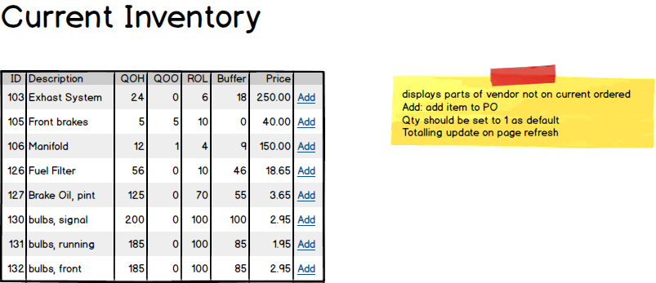

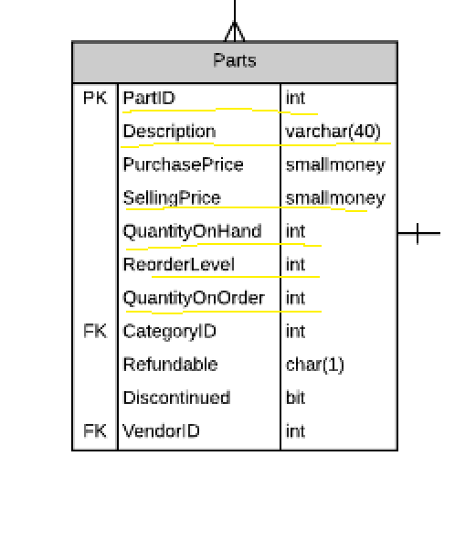

Add Part <asp:buttonLink>

[DataObjectMethod(DataObjectMethodType.Insert)]

Public void AddPart (int PartID, int qty)

Placing Order <asp:buttonLink>

Public void Save (EditCurrentOrder order)

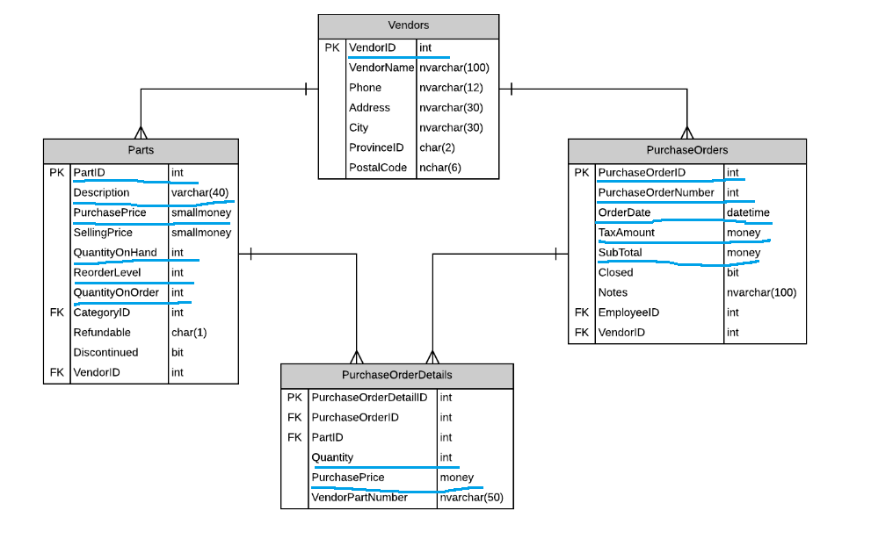

Additional things:

Remove

Update

Public void UpdateCurrentOrder (EditCurrentOrder order)

Delete -- how to generate this?

Public void DeleteCurrentOrder (int PurchaseOrderId)

Clear